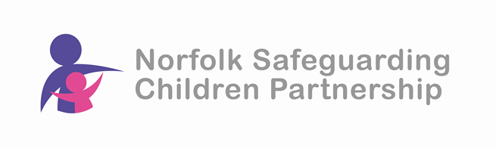
Safeguarding Practice Review Roadshows
Case AO - Jasmine
Spring 2026

Following the publication of Norfolk’s Local Child Safeguarding Practice Review on 13 January, the NSCP is pleased to invite you to share the learning with the you. We have arranged a series of roadshows – mostly in person with one online – in April 2026.

The Learning Objectives:

- Promoting good relational practice
- Greater knowledge of resources available to staff when working with fathers in Norfolk
- Support staff to understand the importance of working with extended family networks, to open up additional support, stability and safety for children and young people
- For participants to understand how to support a young person through creative and therapeutic interventions
- How Joint Agency Group Supervision (JAGS) could support Transitional Safeguarding.

Dates and times

Monday 20th April 2026 - 9.30am to 1pm - The Nest, Horsford

Wednesday 22nd April 2026 - 9.30am to 1pm - South Green Park, Mattishall

Tuesday 28th April 2026 - 9.30am to 1pm - The King Centre, Gt Yarmouth

Wednesday 29th April 2026 - 9.30am to 1pm - Microsoft Teams

These are free events but places are limited so to ensure your place please book asap.

To book your place visit the NSCP website training page:
https://norfolklscp.org.uk/people-working-with-children/nscp-training

